BE 1 Exercises

Oct 30th

# Exercise 1 (Network inspect)

* Go one of the websites that you visit frequently using your browser
  + What is the url ?

[**https://calendar.google.com/calendar/u/0/r**](https://calendar.google.com/calendar/u/0/r)

* Open the developer tools (Inspect) and answer the following
  + What is the IP address of the server host
  + How many http(s) request were made

* + What are the different types returned from all of the requests

Fetch/XHR, JS, CSS, Img, Media, Font, Doc, Manifest, Other

* + What was the largest file returned

A document file ‘r’

* + How many ms did it take?

450ms

# Exercise 2 (Simple Node Server)

* Go to <https://www.npmjs.com/package/http-server>
* Install the required packages
* Serve your website using the (http-server) On port 2
* Go to http://localhost:2
* Open inspect > Network
* Take a screenshot and upload it

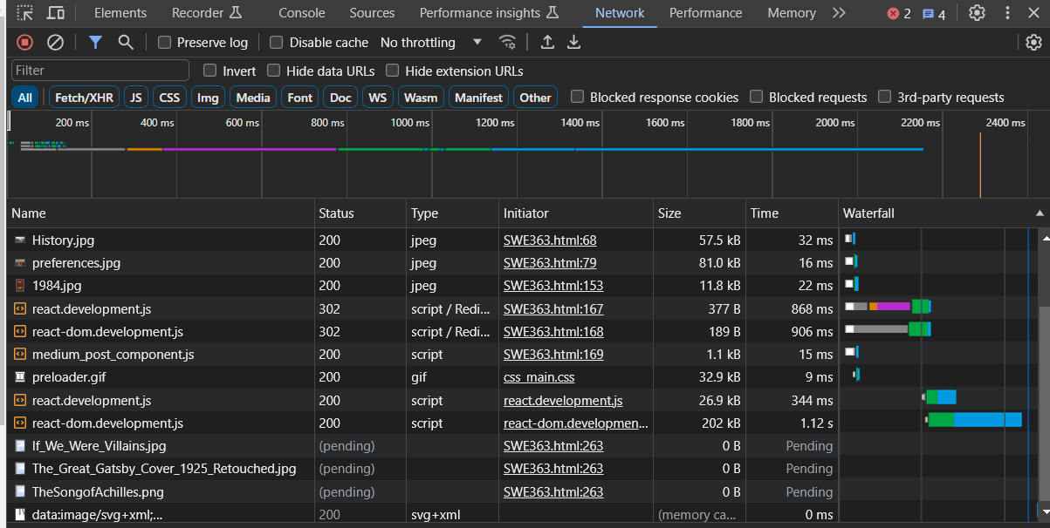

# Exercise 3 (Domain Name)

* Go to GoDaddy.com
* Find a domain name for your

